Visualizations and Insights

(Added LocationID to each zone on the map for the ease of understanding, by calculating representative point for each polygon.)

### Most Generous People:

1. This visualization shows all the zones of New York City and what is the average tip given in these zones.
2. Zones with LocationID=162,132,138,215,161,50,186,114,107 are the zones where tips worth 100$ or more was given to the taxi driver.
3. Then there are very few areas with tips between 80$ to 100$, as seen in the visualization.
4. In rest of zones tips given are below 40$ which seems reasonable.
5. High tips in certain zones indicate more rich people live in these zones. Most of these big tip zones are in Manhattan.

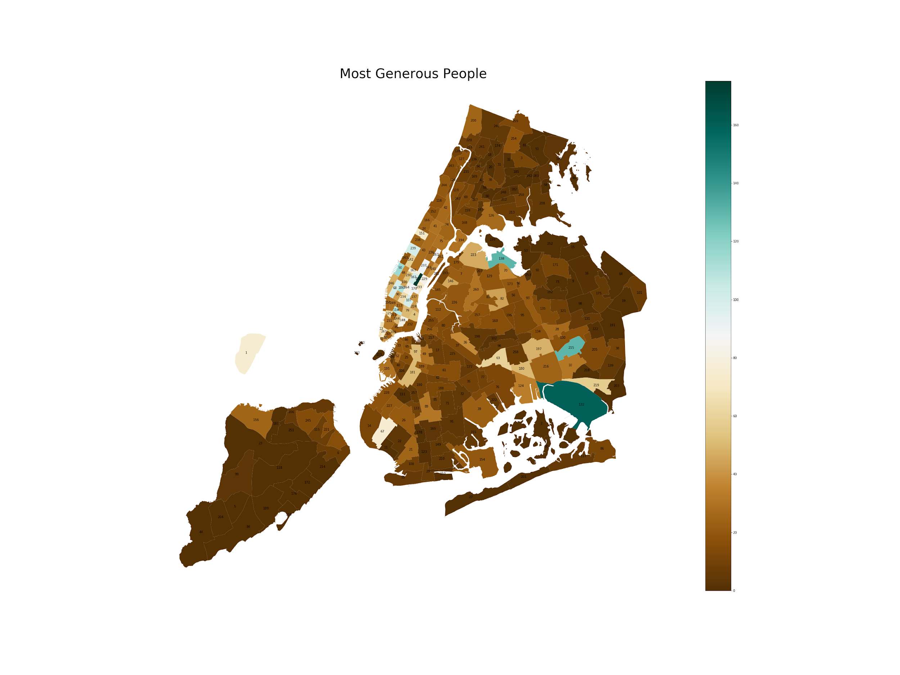

### Payment Trends

1. Given in the table are 6 payment methods out of which 1=Credit card, 2=Cash, 3=No charge are widely used.
2. 213 and 235 are the zones with 3 as the prominent method which could mean that at the time an offer/scheme was introduced which gave customers free rides. This seems rather a good promotional strategy for attracting people to use taxis for travelling around. Also data is centered around New Year's Days, so it is a good time for making profits.
3. There are some zones with 0 as payment method which means data for them was not in given table or maybe taxis are still not operational in these areas.
4. This visualization gives a clue to taxi companies to make use of methods 1,2 and 3 more easier and user friendly as customers use them the most.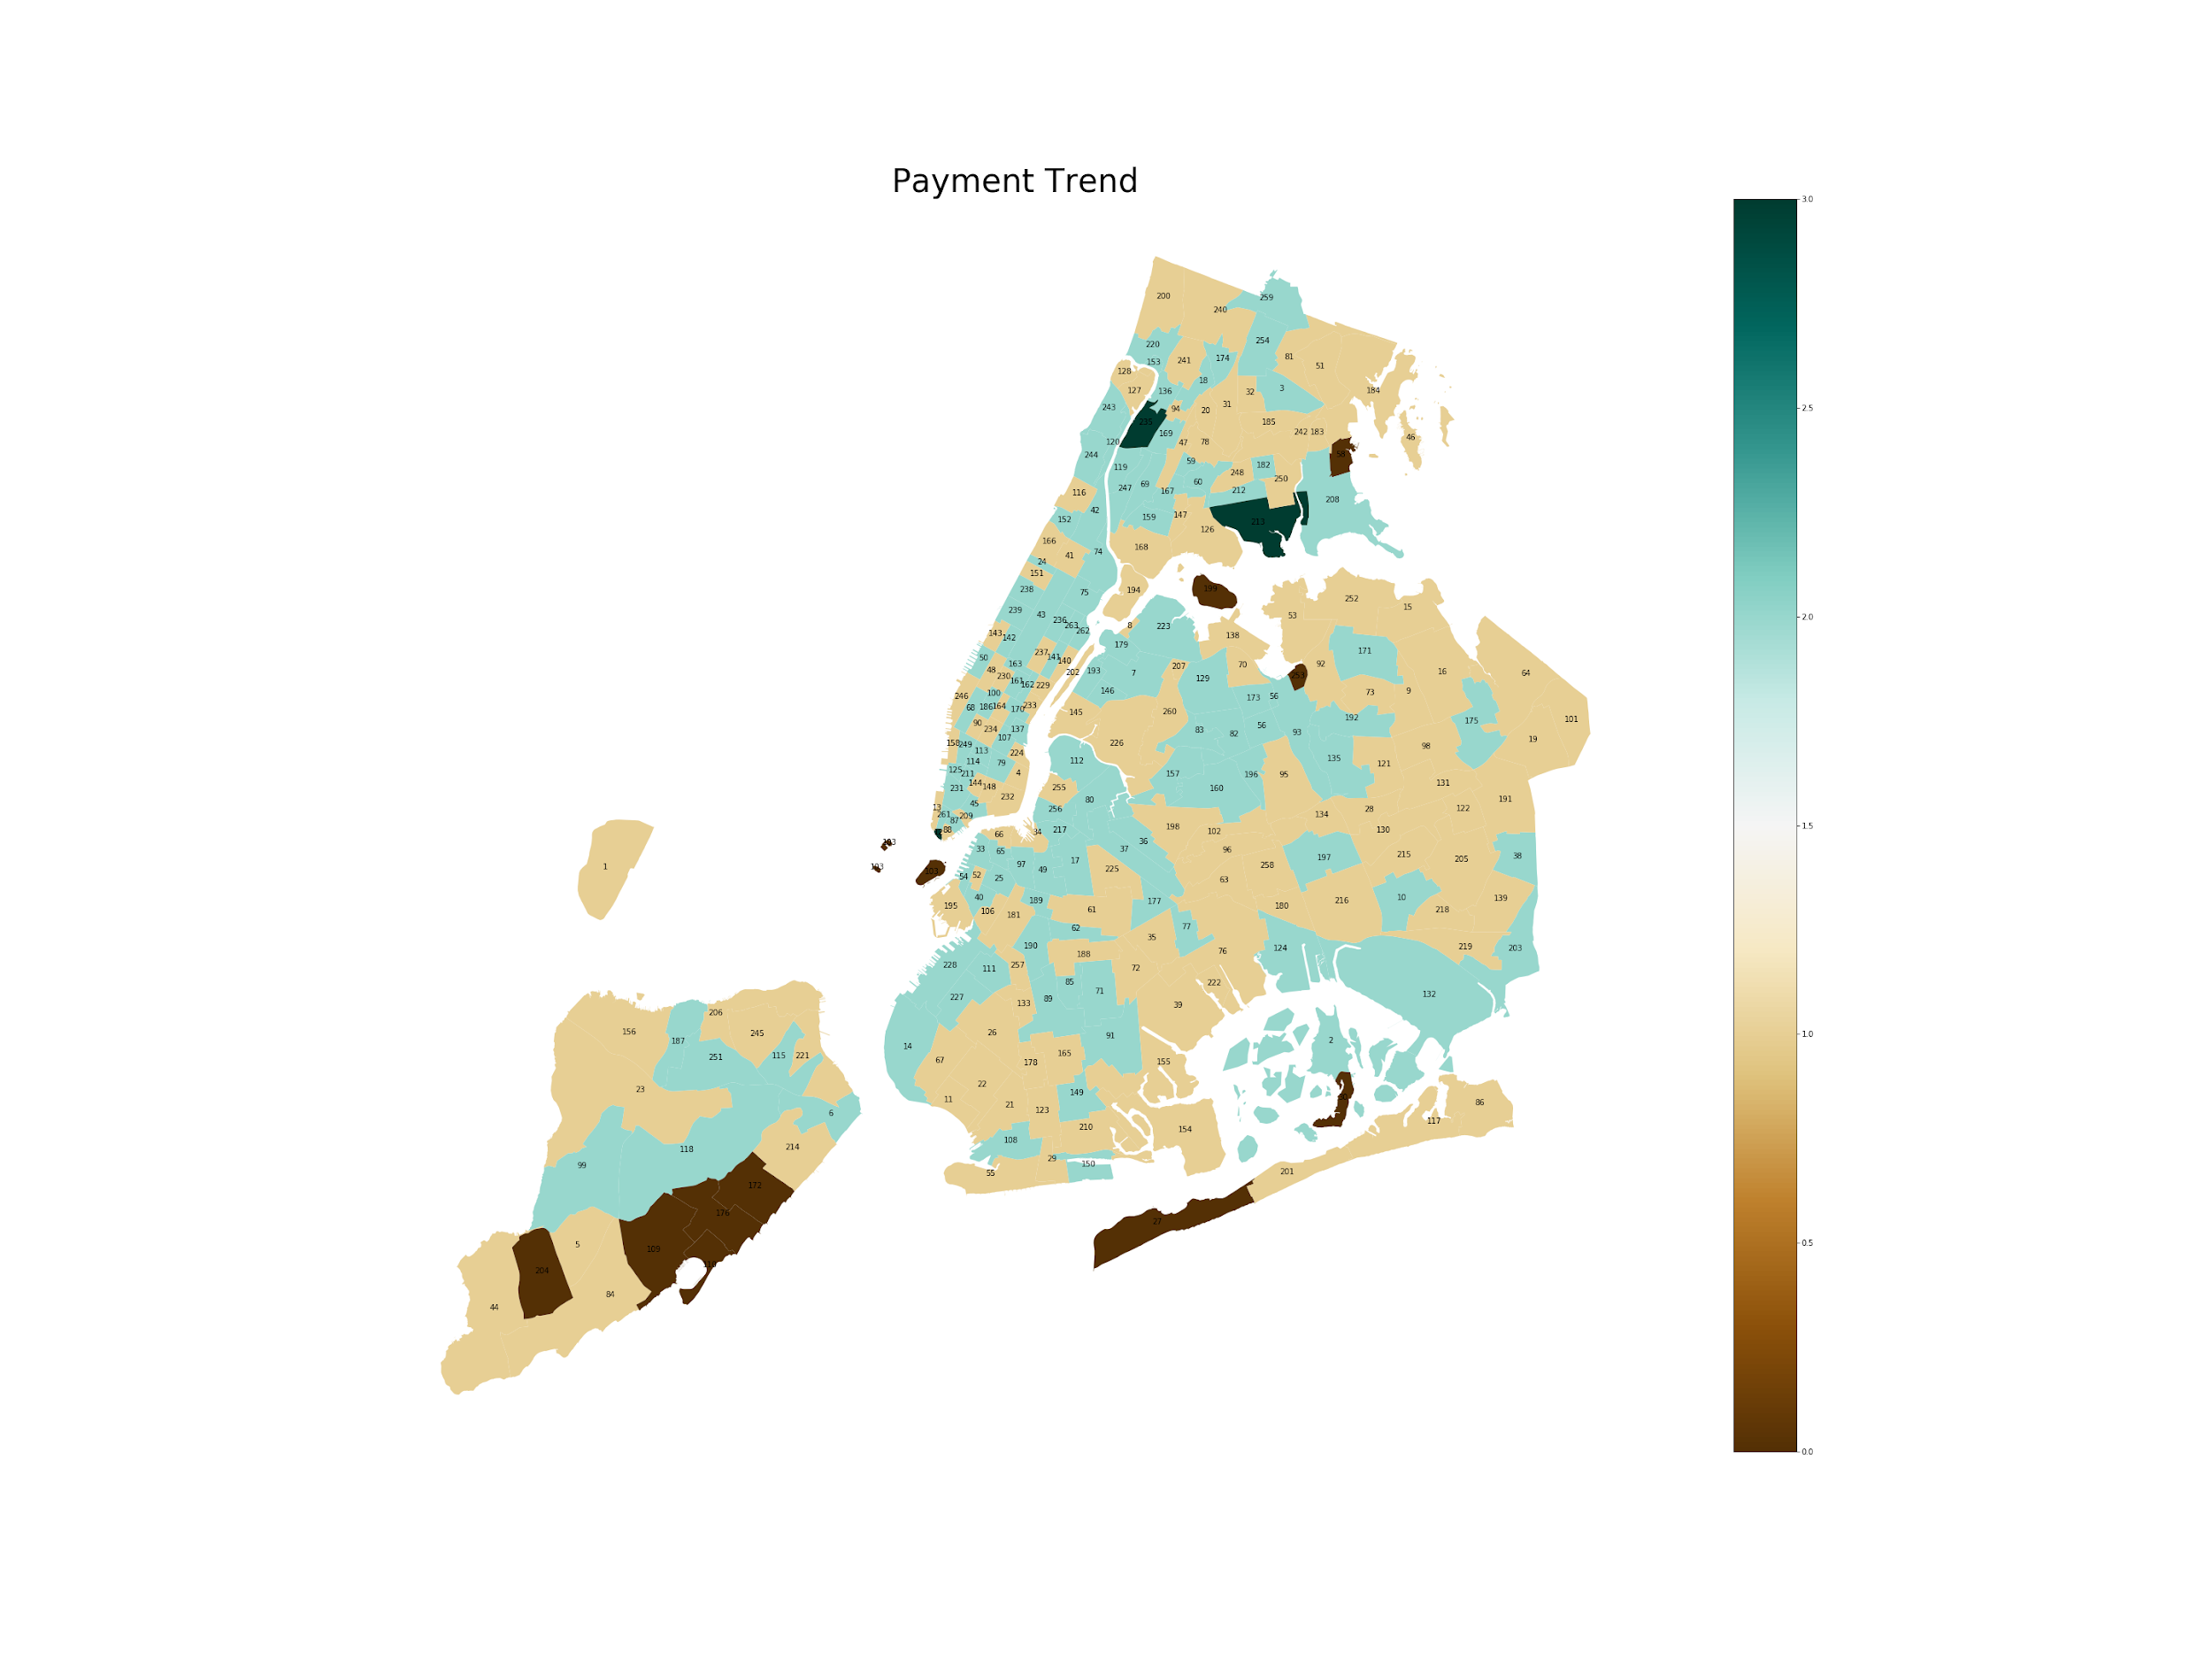

### 

### Time window for Highest Revenue along with Date and Time comparison:

1. This visualizations show time window of highest revenue for each zone.
2. First look at the maps tells us that the highest revenue was generated after 10 am
3. Looking closely we have few zones with the time window between 5 am and 10 am also.
4. 132 along with few others have time window between after midnight.

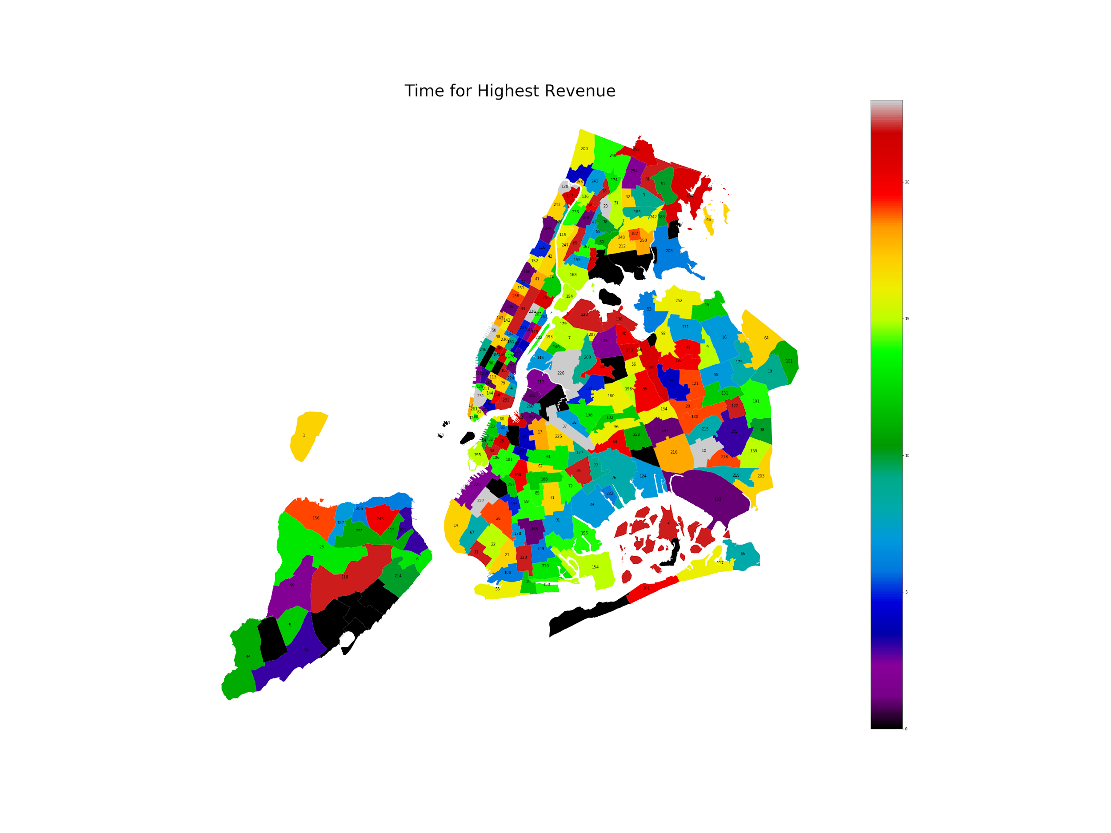

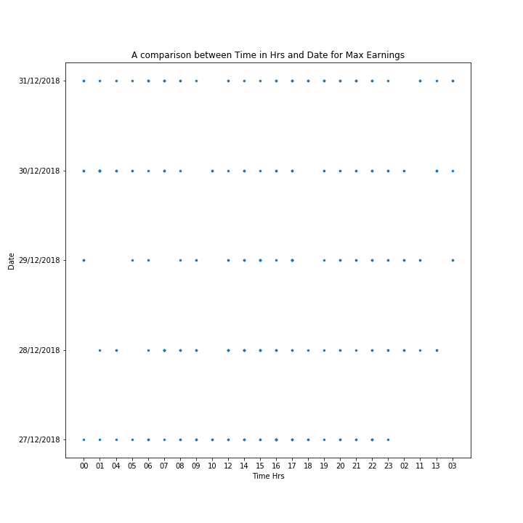

1. The scatter plot gives further understanding by comparing Dates with Hours of the day.
2. 31/12/2018 is the day before the New Year and at each hour highest revenue was generated except for 10 am and 2 am.
3. The plot also signifies that on these 5 days use of the taxis was made the most by the people and also high revenues were generated.
4. It is a good hint for taxi companies as when to launch new features and schemes at this time of the year so that they can make high profit.

### Number of cases for Trip Distance Zero but Money Paid:

1. This visualization indicates that even though distance travelled was zero money was still paid.
2. It means that there can be cases of cheating where taxi drivers did not start the distance calculator on the app or taxi meter as trip amount is calculated based on distance travelled.
3. There are also strong chances of it being a technical issue with the app.
4. LocationID 228,244,188,201,165,155 are the zones with most such cases.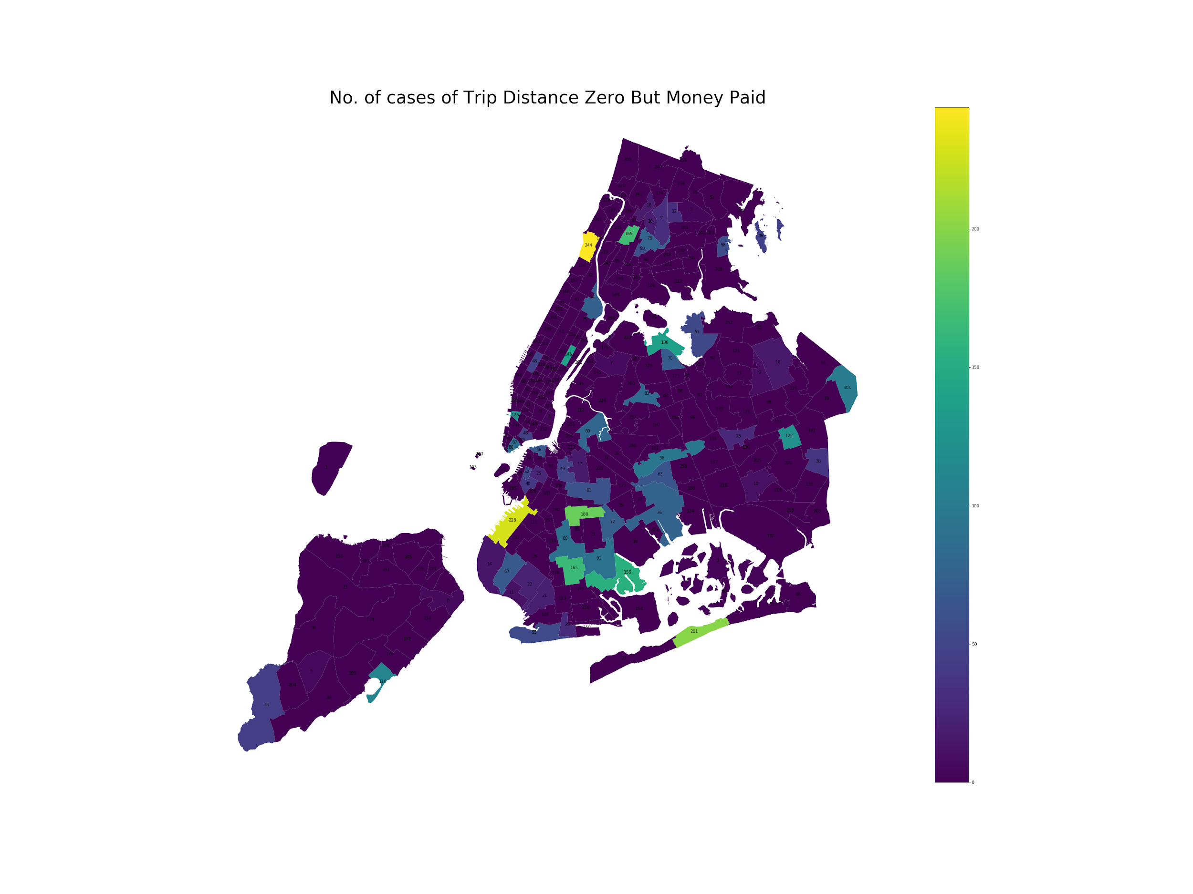

### Average Speed of taxis in each zone:

1. This visualization shows average speed of taxis in each zone.
2. Majority of zones have average speeds between 10 to 40km/hr.
3. Low speeds indicate high traffic in those zones.
4. Some zones have speeds greater than 50km/hr which depends on the traffic rules as well as what kind of roads were used the most by the taxis.

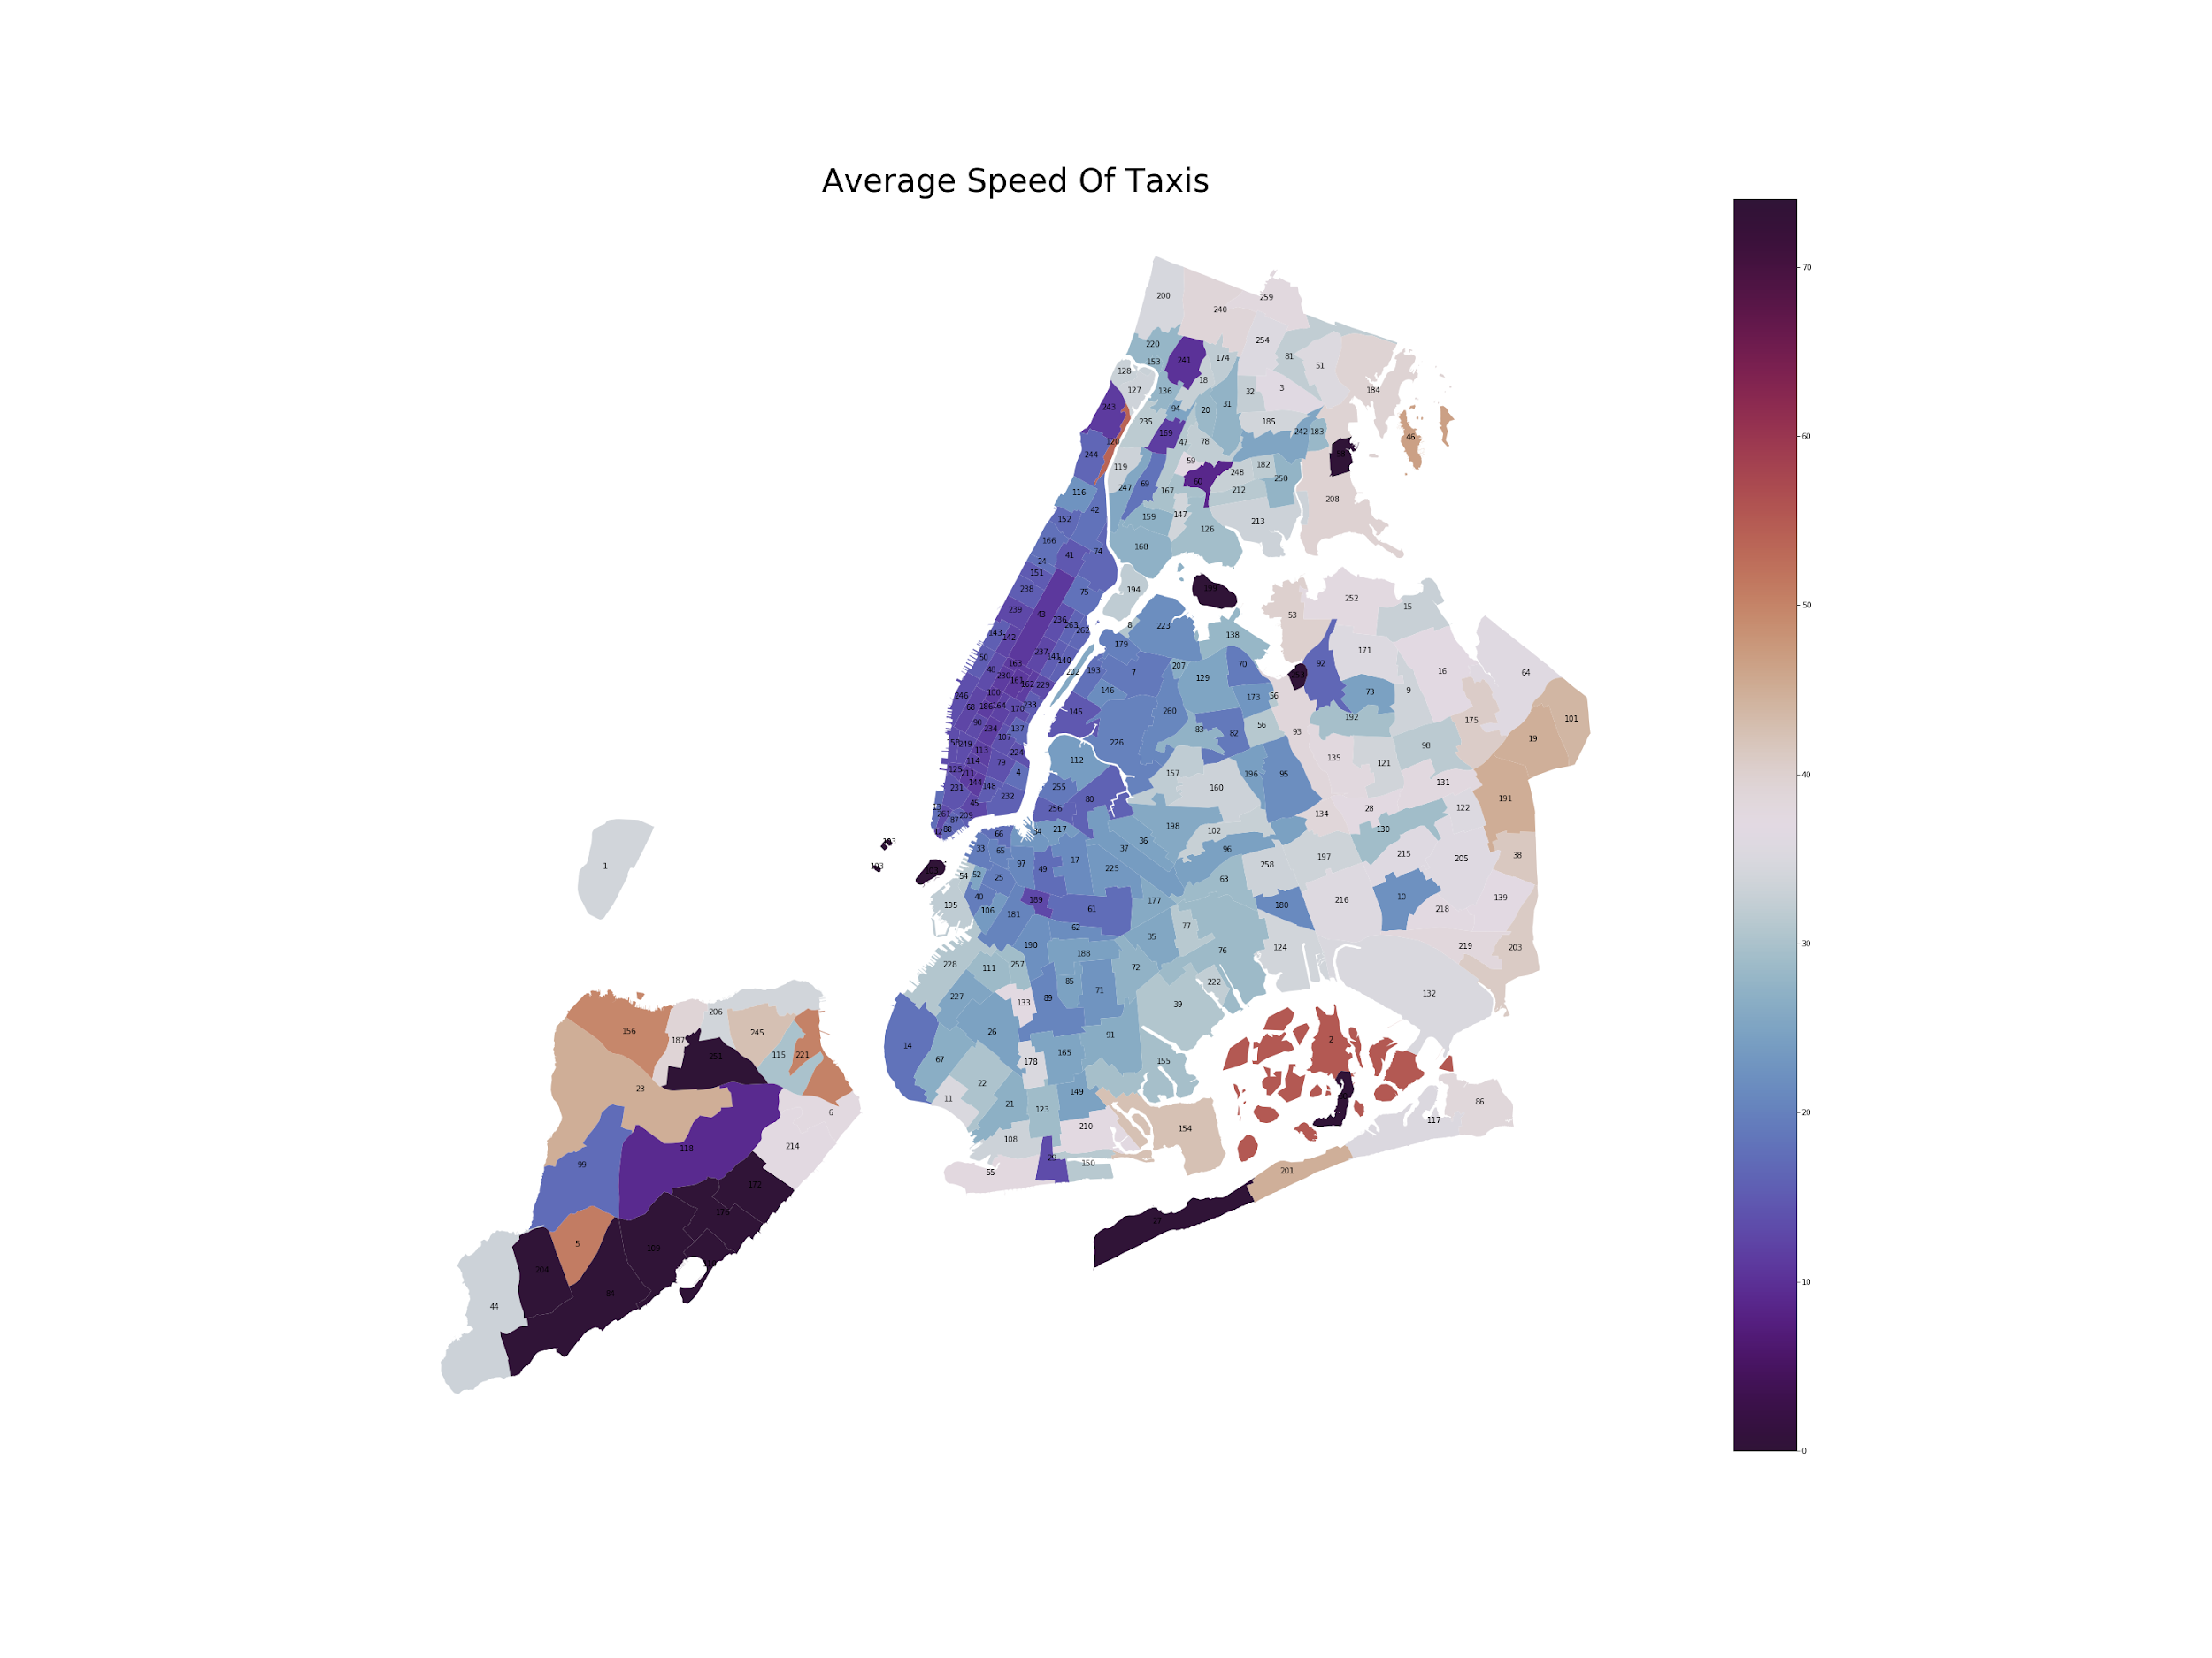

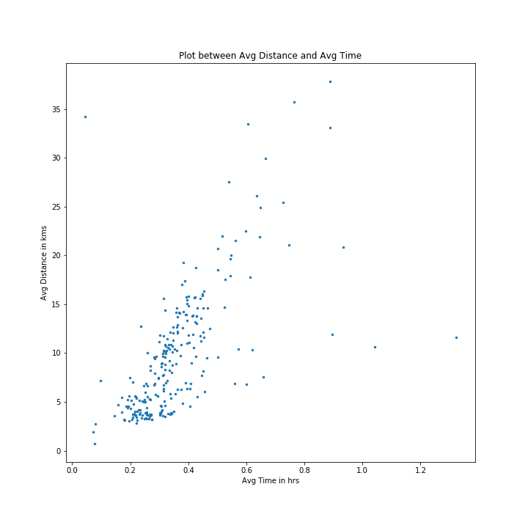

1. We have some outliers too for example marker(84 LocationID) with average distance 34km and average time less than 0.1 hrs has average speed 763km/hr as calculated by formula avg distance/avg time. Other makers on extremes indicate very high or very low average speeds which can technical or other issues.
2. The plot also shows a trend of increasing time with increasing distance.
3. It also depicts that people use taxis for travelling distances between 3 to 20 kms on average.
4. Ranges of time depicts traffic concentration in each zone so taxi companies can update the path to destinations accordingly.